CSA1413
COMPILER DESIGN
Name: Haresh Kumar N L
Reg No: 192425009
Word Replacement Using Lex

Aim:
To write a Lex program to replace the word "hello" with "hi" in the given input text.

Algorithm:
- Start the program.
- Include the required header file.
- Define a Lex rule to replace "hello" with "hi".
- Use ECHO to print all other characters unchanged.
- Call yylex() to process the input text.
- Display the modified text.
- Stop the program.

Pseudocode:
BEGIN
Include stdio.h
IF input matches "hello" THEN
Print "hi"
ELSE
Print the input character unchanged
END IF
CALL yylex()
END

Code:
%{
#include <stdio.h>
%}
%%
hello { printf("hi"); }
. { ECHO; }
\n { ECHO; }
%%
int yywrap(void)
{
return 1;
}
int main(void)
{
yylex();
return 0;
}

Input:
hello everyone
welcome to hello world

Output:
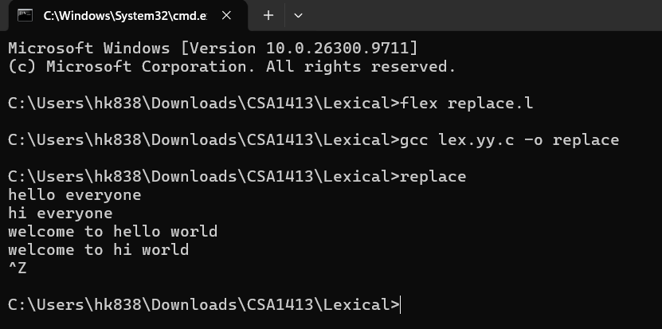

Result:
Thus, the Lex program to replace the word "hello" with "hi" in the given input text was executed successfully.

